ROBOTICS PROCESS AUTOMATION



**INDEX**

|  |  |  |  |
| --- | --- | --- | --- |
| **PRACT NO.** | **PRACTICAL** | **PAGE NO** | **SIGN** |
| 1. | 1. Create a simple sequence-based project. 2. Create a simple flowchart-based project 3. Create an UiPath Robot which can empty recycle bin in Gmail solely on basis of recording. | 4 – 15 |  |
| 2. | 1. Automate UiPath Number Calculation (Addition, Subtraction, Multiplication, Division of numbers). 2. Create an automation UiPath project using different types of variables   (number, datetime, Boolean, generic, array, data table) | 16-21 |  |
| 3. | 1. Create an automation UiPath Project using decision statements. 2. Create an automation UiPath Project using looping statements | 22- 29 |  |
| 4. | 1. Automate any process using basic recording 2. Automate any process using desktop recording 3. Automate any process using web recording. | 30-36 |  |
| 5. | Consider an array of names. We have to find out how many of these start with the letter “a” Create an automation where the number of names starting with “a” is counted and the  result is displayed. | 37-38 |  |

**Practical no 1**

# Create a simple sequence-based project.

**Aim:** Use two input dialogs for First Name and Last Name store in a variable and show in Message Box.

## Steps:

* 1. Open UiPath Studio and click on **Blank** to start a fresh project. Give it a meaningful name.

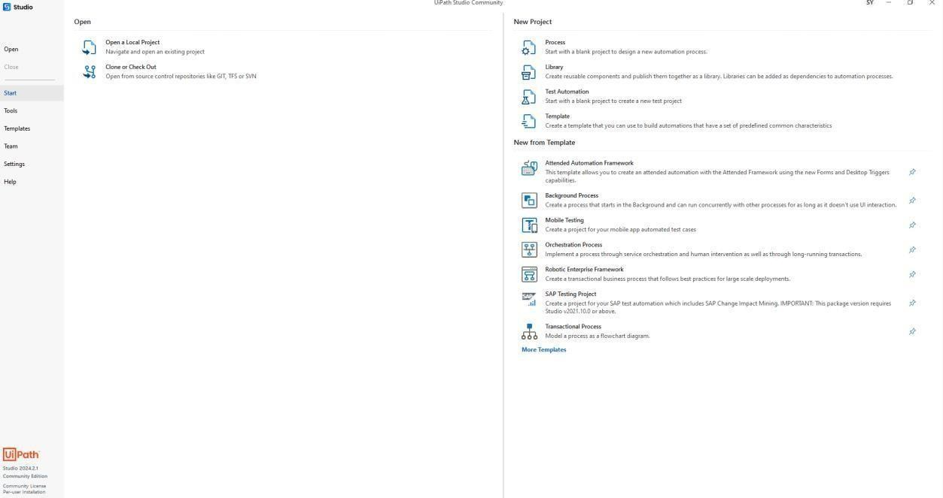

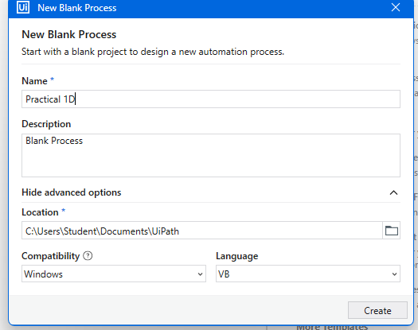

* 1. On the Designer panel, drag and drop a **Sequence** activity from the **Activities** panel.

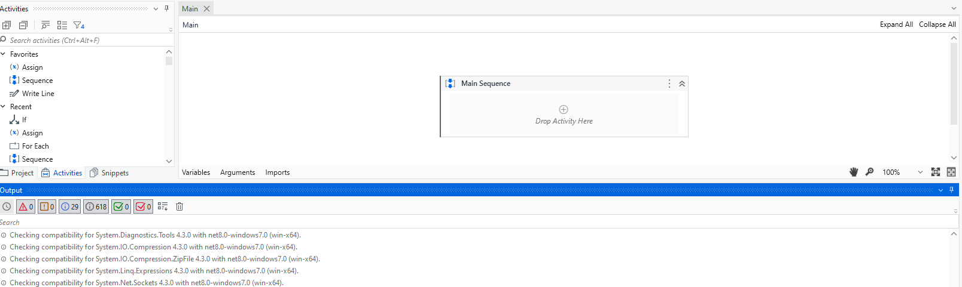

* 1. Search for **Input dialog** in the Search panel of the **Activities** panel. Drag and drop the **Input dialog** activity inside the **Sequence**.

Write the appropriate message on the **Label** of this **Input dialog** to ask for the user's name. Inour case, we have put in “Enter First Name”

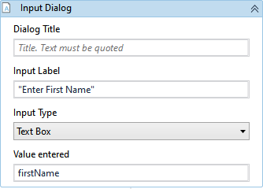

* 1. Drag another **Input dialog** activity into the **Sequence**. Write the Label as “Enter Last Name”
  2. Drag and drop a **Message box** activity into the **Sequence**

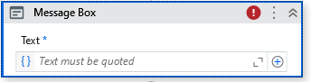

* 1. Next, create two **variables** and give them the desired names. These variables will receive the textthat the user has entered in the **Input dialog** boxes.



* 1. We now have to specify the **Result** property (in the **Properties** panel) of the **Input dialog** box.On specifying the variable name there, it will receive the text that the user entered.

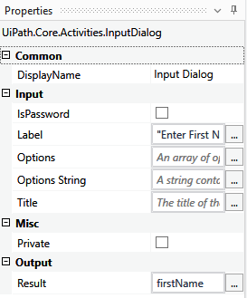 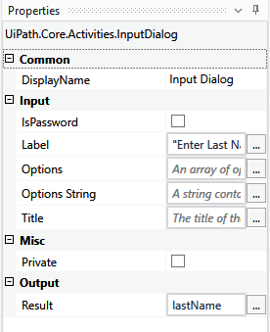

* 1. Specify the variables that we have created with other text in the Text area of the **Message box**.



* 1. Hit the **Debug** button and see the result.

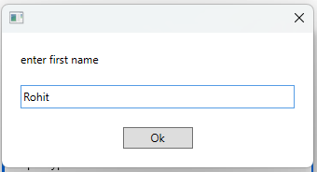

# Create a simple flowchart-based project.

**Aim:** Use two input dialogs for First Name and Last Name store in a variable andshow in Message Box.

## Steps:

1. Open UiPath Studio and click on **Blank** to start a fresh project. Give it a meaningful name.

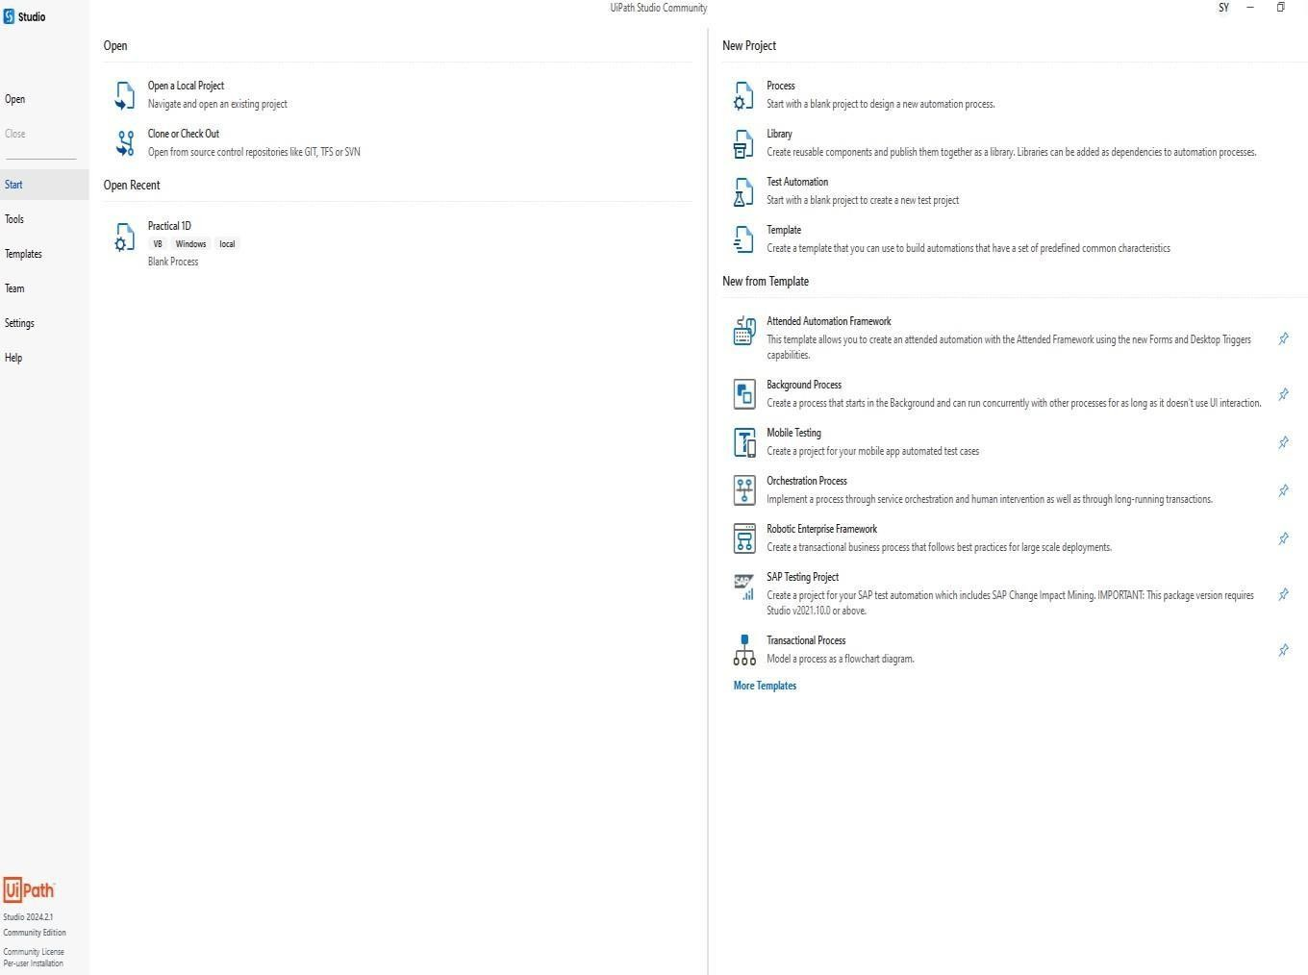

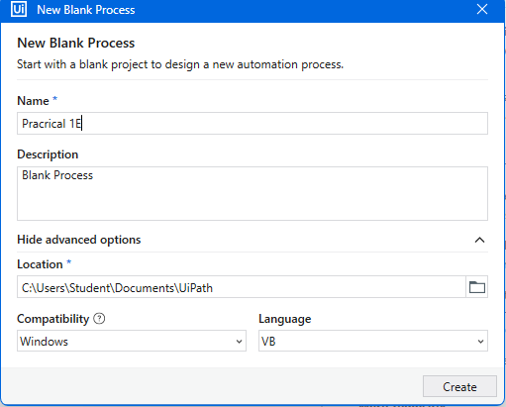

1. On the Designer panel, drag and drop a **Flowchart** activity from the **Activities** panel. doubleclick into Flowchart and drag **Sequence** activity.

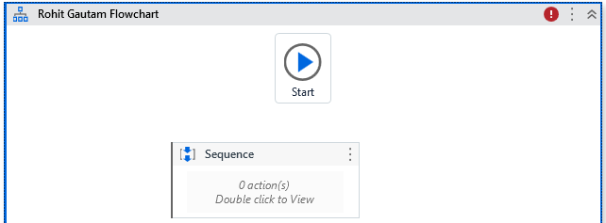

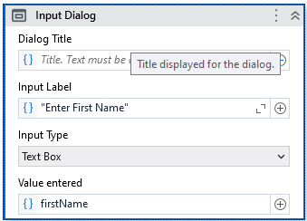

1. Search for **Input dialog** in the Search panel of the **Activities** panel. Drag and drop the

**Inputdialog** activity inside the **Sequence.**

Write the appropriate message on the **Label** of this **Input dialog** to ask for the user's name. Inour case, we have put in “Enter First Name”

1. Drag another **Input dialog** activity into the **Sequence**

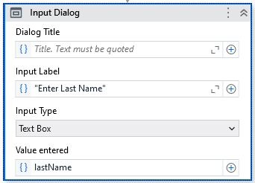

Write the Label as “Enter Last Name”

1. Drag and drop a **Message box** activity into the **Sequence**.

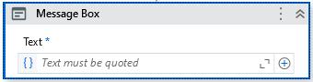

1. Next, create two **variables** and give them the desired names.

These variables will receive the textthat the user has entered in the **Input dialog** boxes.



1. We now have to specify the **Result** property (in the **Properties** panel) of the **Input dialog** box.On specifying the variable name there, it will receive the text that the user entered.



1. Specify the variables that we have created with other text in the Text area of the **Message box**.



1. We need to connect the **Sequence** to the **Start** icon. This can be done by right-clicking on the

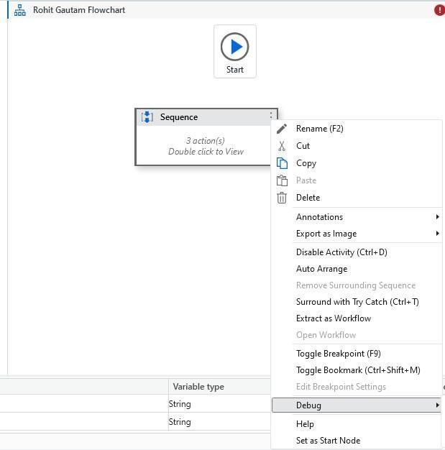

**Sequence** activity and choosing the **Set as Start node** option.

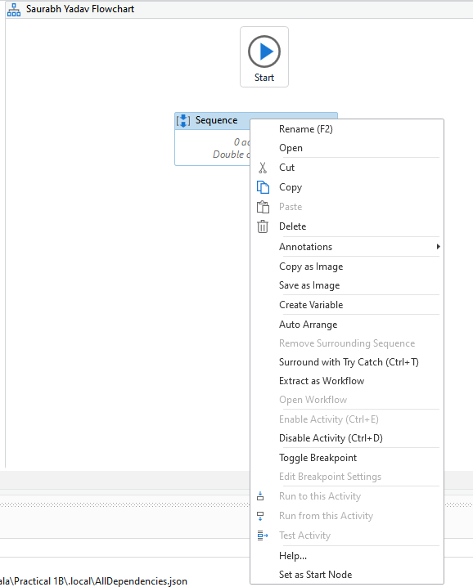

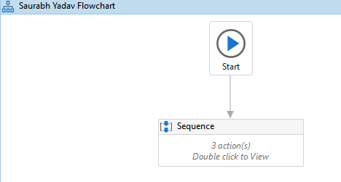

1. Hit the **Debug** button and see the result.

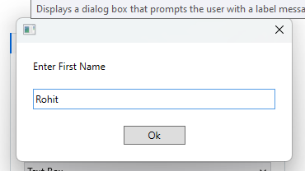

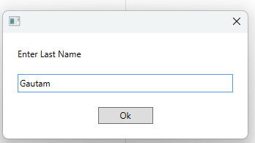 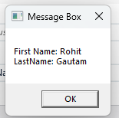

# Create an UiPath Robot which can empty recycle bin in Gmail solely on basis of recording.

**Aim:** Use Web Recorder toempty trash in gmail.

## Steps:

1. Open UiPath Studio and click on **Blank** to start a fresh project. Give it a meaningful name.

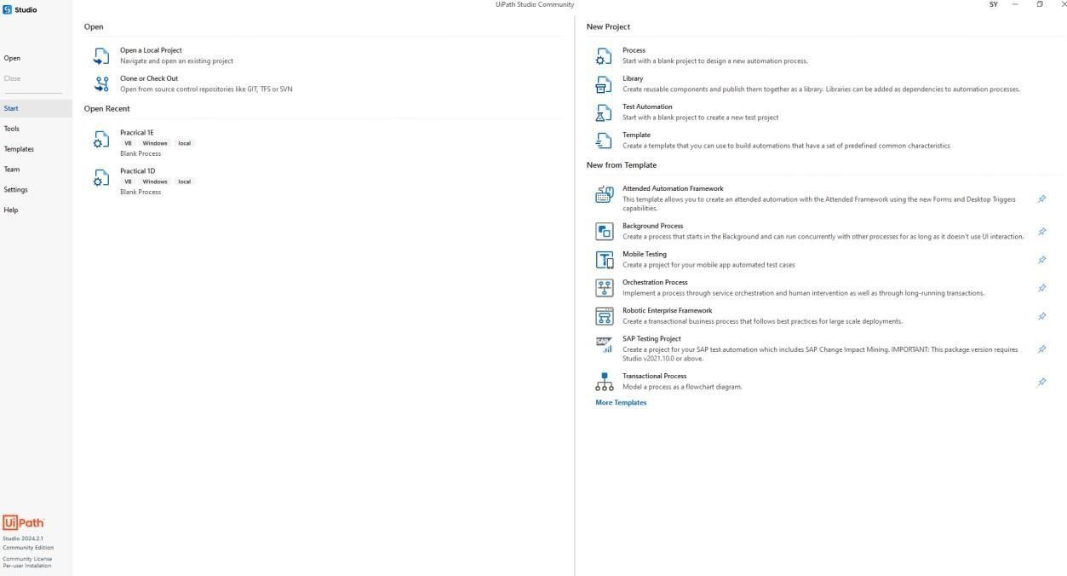

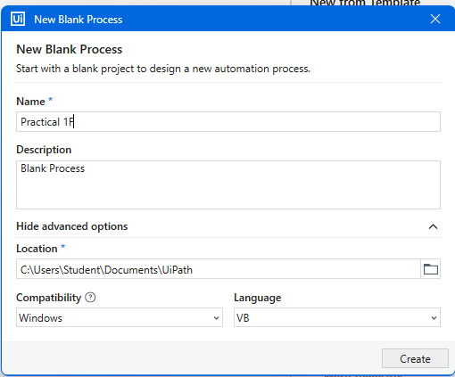

1. Choose Web recorder from the Recording drop-down list:

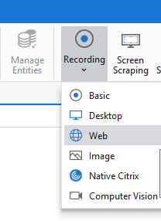

c.Open a Chrome browser and go to gmail.com.

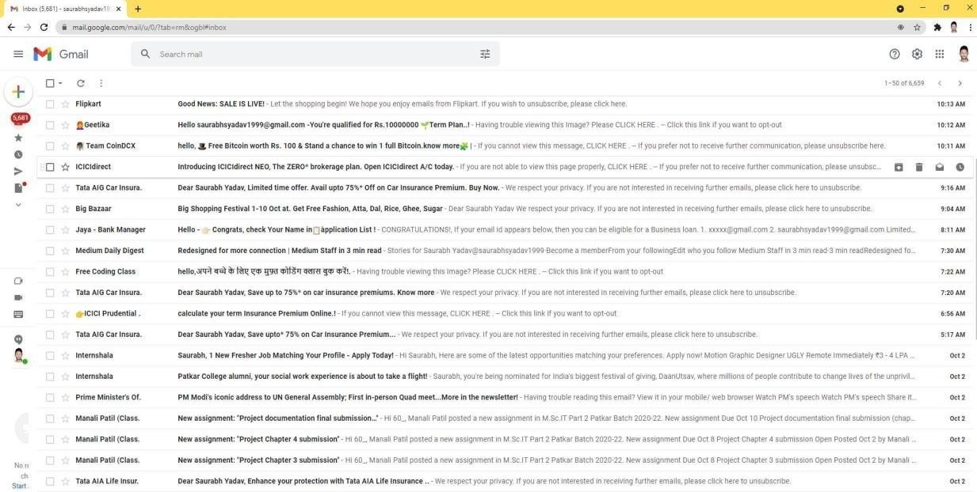

* 1. On the web recording panel click on “Open Browser” option and select the chrome window. Inthe url prompt type gmail.com.

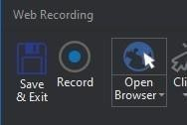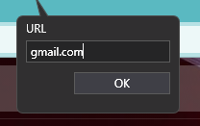

* 1. Now start the recording and click into the search bar of Gmail. Type “in: trash” in the type intoprompt and press enter.

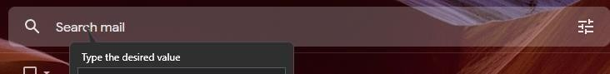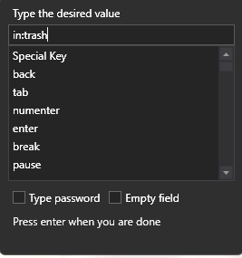

* 1. From the drop down click on the in:trash option.

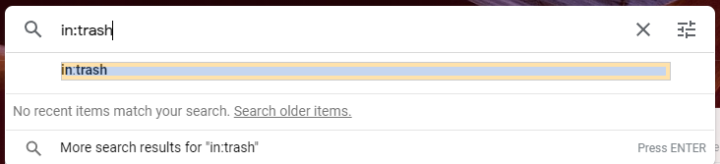

* 1. Once in the trash section of Gmail. Click on the checkbox button to select allthe mail of thecurrent page. Then click on Delete Forever button that appears.

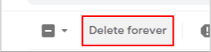

* 1. Press Esc key and click on Save and Exit option in the web recording panel.



* 1. Now Run the program by clicking on Debug and see the output

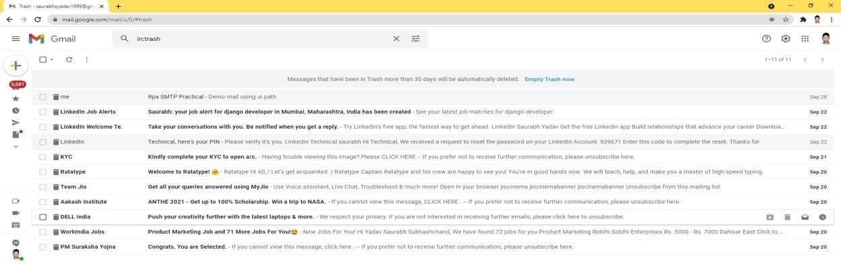

**Practical No 2**

# Automate UiPath Number Calculation (Addition, Subtraction, Multiplication, Division ofnumbers).

**Aim:** Use two Input dialogs for Numbers and do following calculations and show in Message Box. Steps:

* 1. 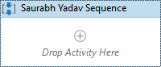Create a new Blank Project and give it an appropriate name. Drag a Sequence activity from Activity tab.
  2. Search Input Dialog activity and drag and drop the activity twice.

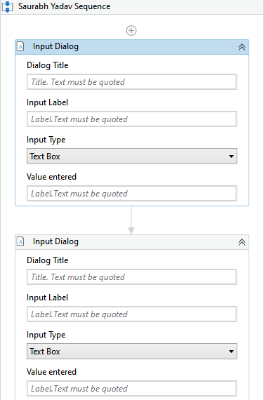

Give the first input dialog label as “Enter first number”.

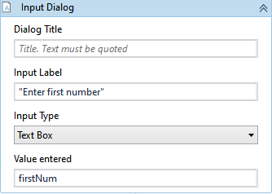

Give the second dialog label as “Enter second number”.

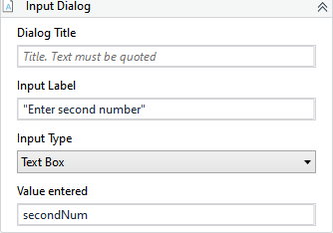

* 1. Create the variables to store both inputs, then enter the variables in the input dialog Result attributes.



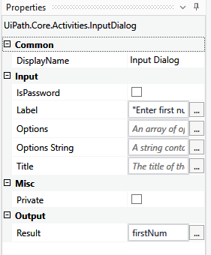 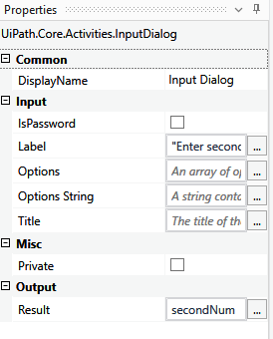

* 1. Drag and drop message box four times and perform the addition, subtraction, multiplication and division operation in each of the message boxes.

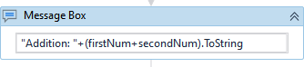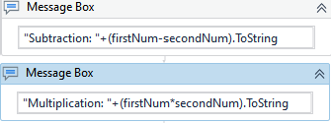

* 1. 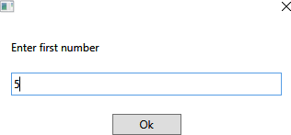Hit the **Debug** button and see the result

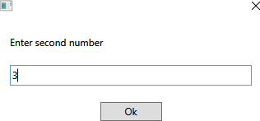

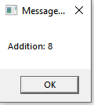 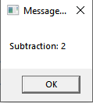 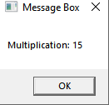 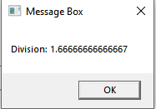

## Create an automation UiPath project using different types of variables (number, datetime, Boolean, generic, array, data table)

**Aim:** Create Different type of variable and provide default value and show in Message Box. Steps:

1. 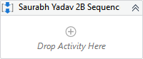Create a new Blank Project and give it an appropriate name. Drag a Sequence activity from Activity tab.
2. Create number(Int32), datetime, Boolean, string, generic, array variables andassign them default value.

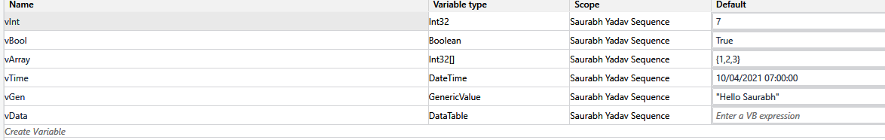

1. Create a datable variable and add a build dataTable activity.
2. 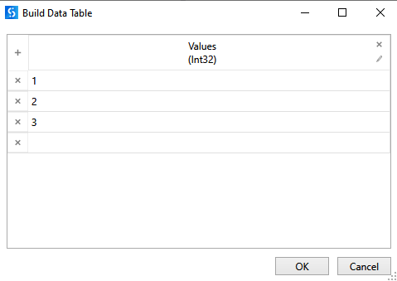Create the values of data table.
3. Add message box to show the number, datetime, Boolean, string, and generic variable.

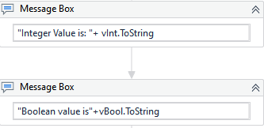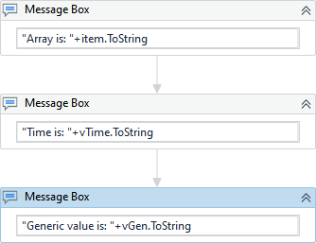

1. Add for each activity and message box to show values of array variable.

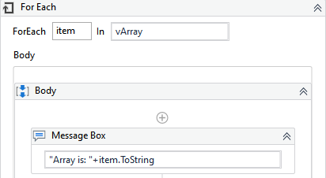

## Output:

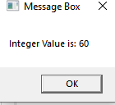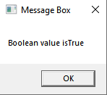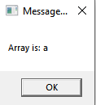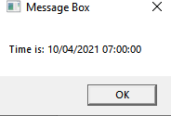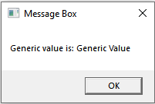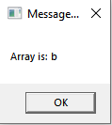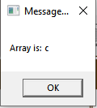

**Practical no 3**

## Create an automation UiPath Project using decision statements.

**Aim:** Use one input dialog for Number, create a process to find provided Number is odd or even using condition (Flow Chart).

Steps:

* 1. 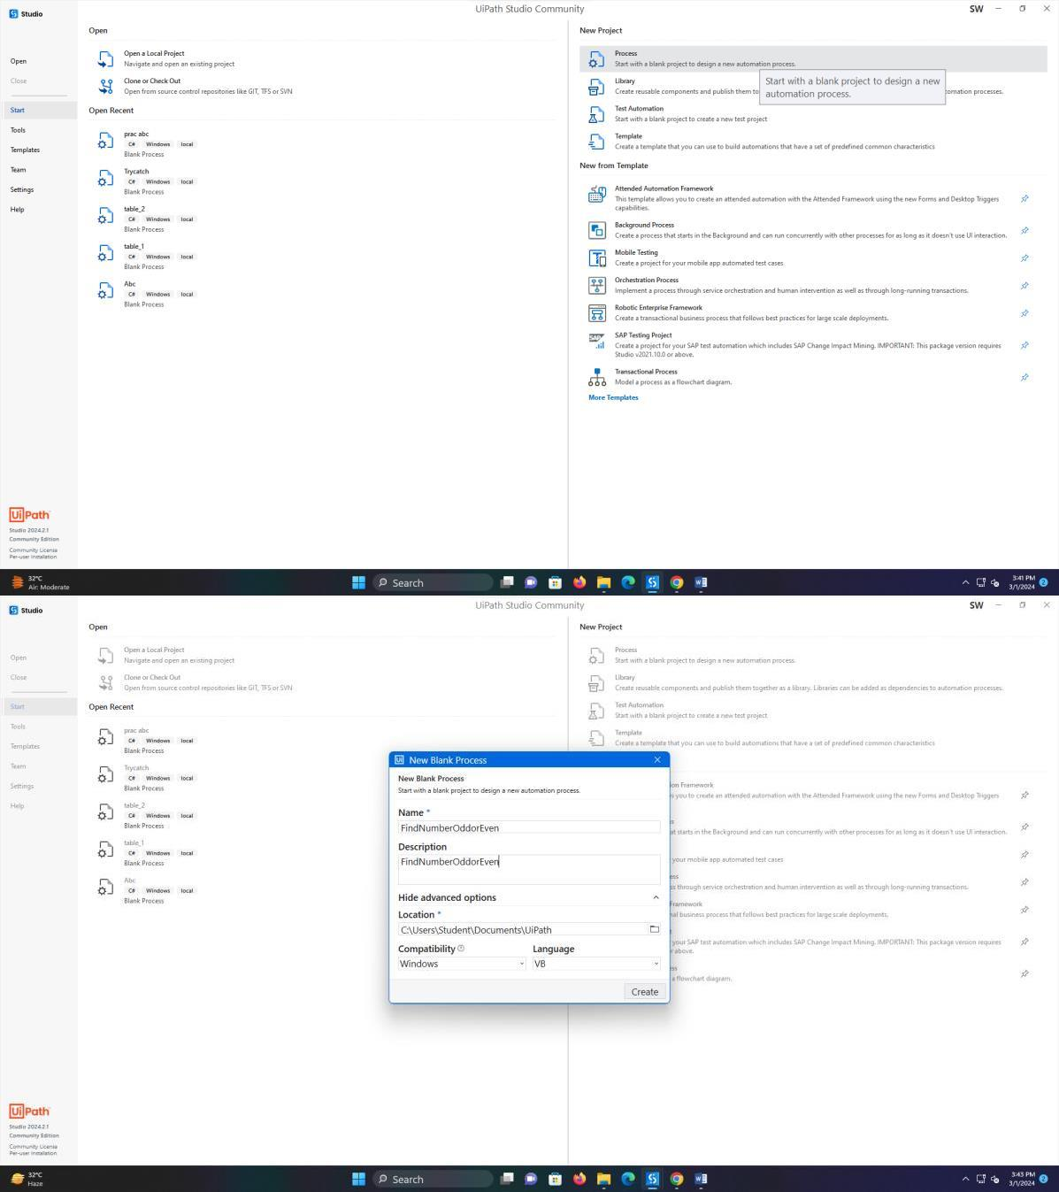Create a new Blank Project and give it an appropriate name. Drag a Flowchart activity from Activity tab.

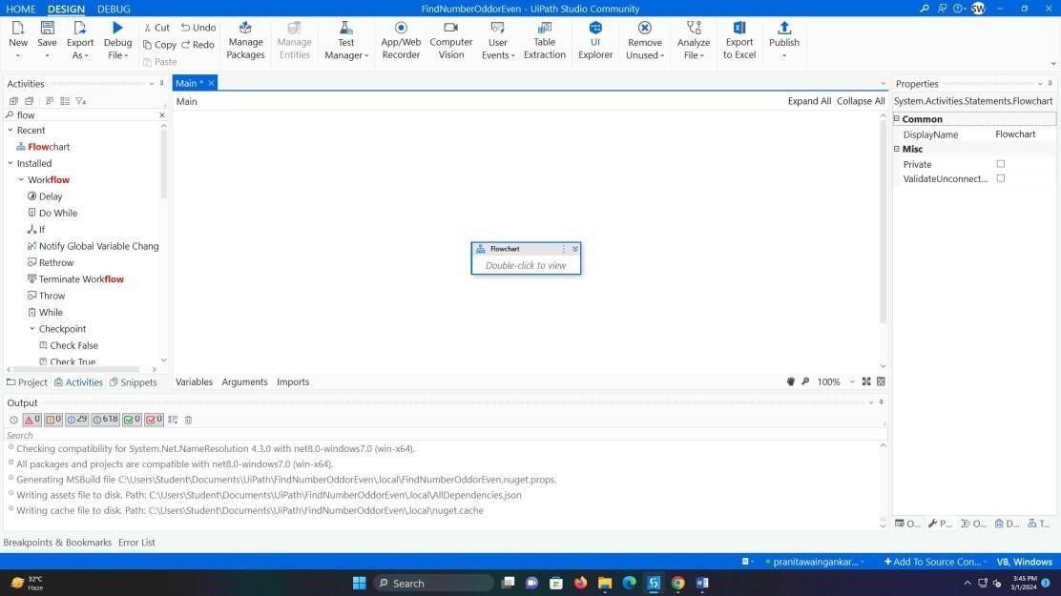

* 1. Double click on flowchart and drag a sequence activity.

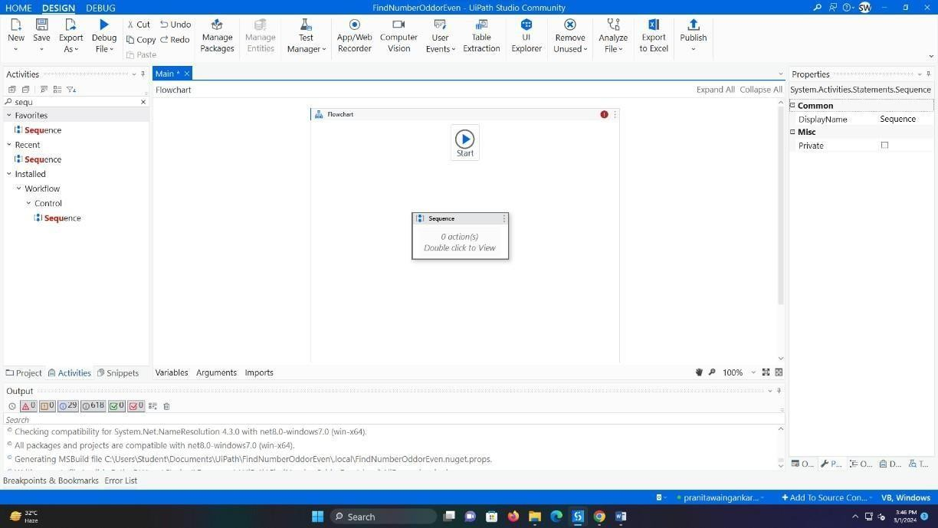

* 1. Drag an Input Dialog activity and give label “Enter the number”.

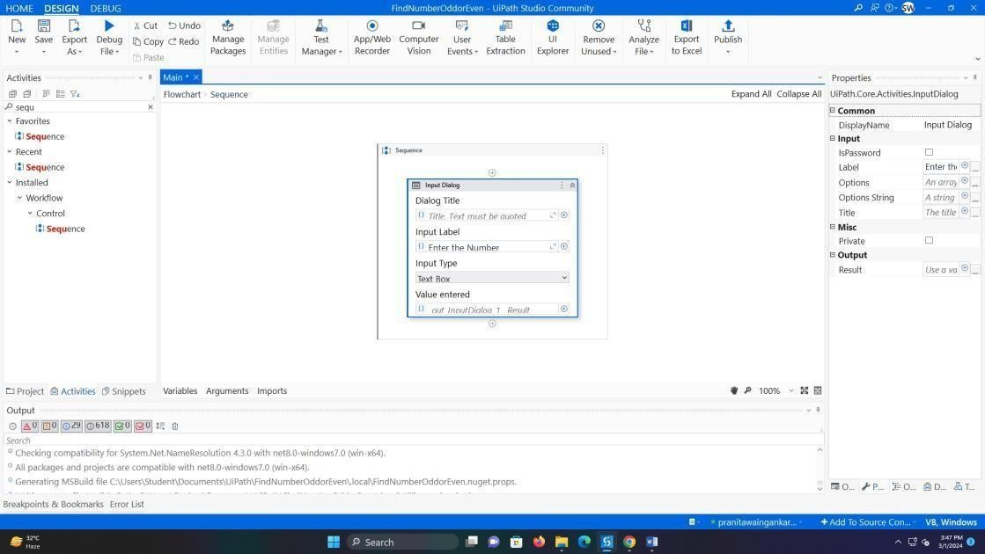

* 1. Create a variable of Int32 type and enter the variable in result attribute of Input Dialog.

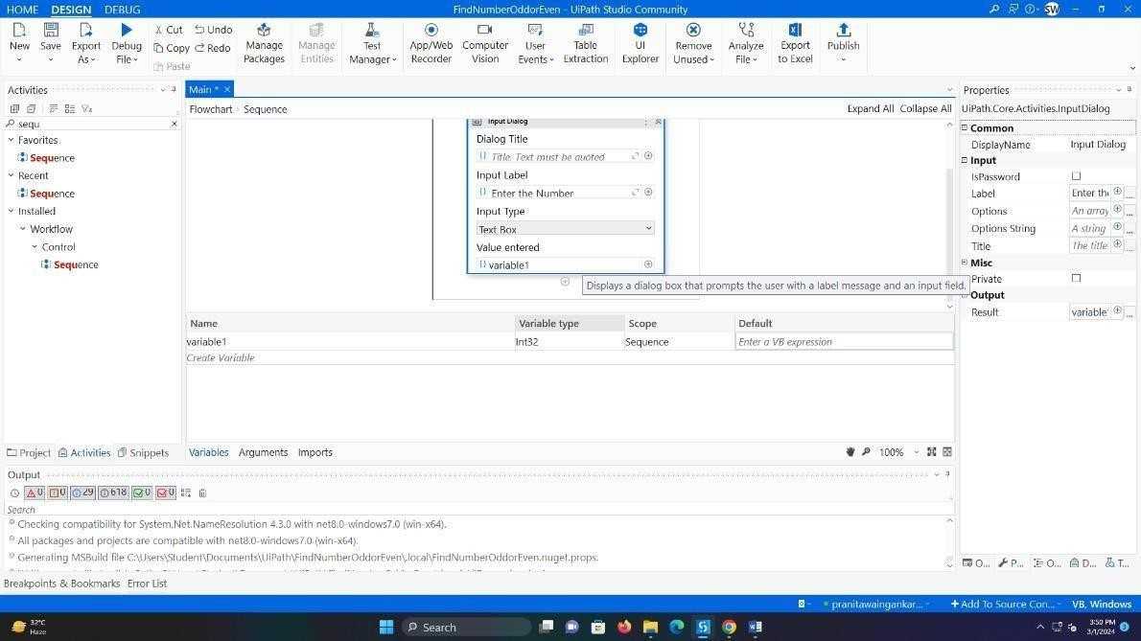

* 1. 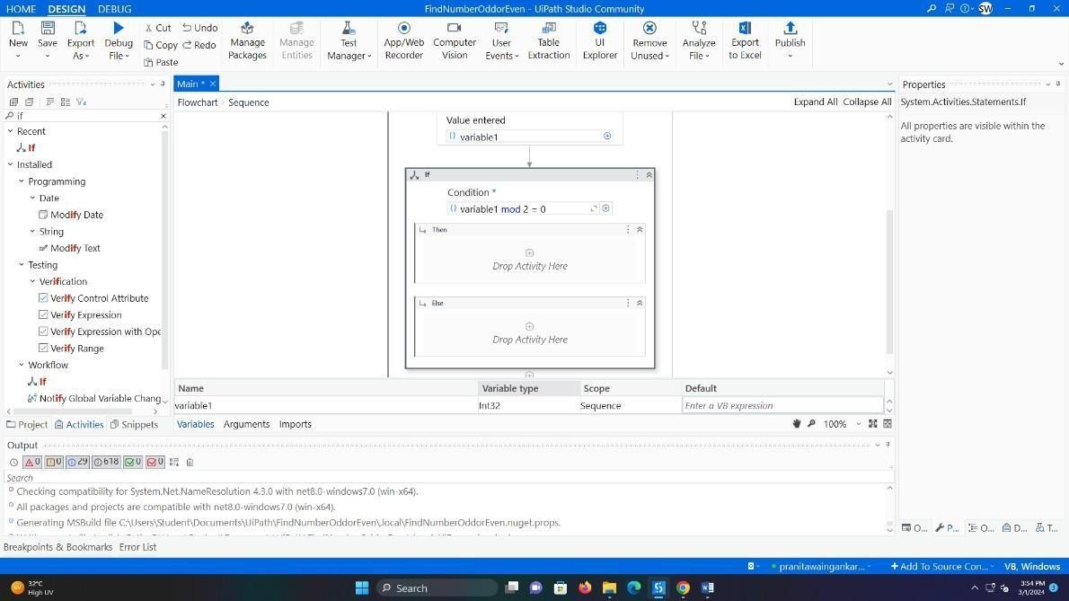Write the following expression in Condition: num mod 2 = 0.
  2. In the Message Box in then part write “Number is even” and in the Message Box in else part write “Number is odd”.

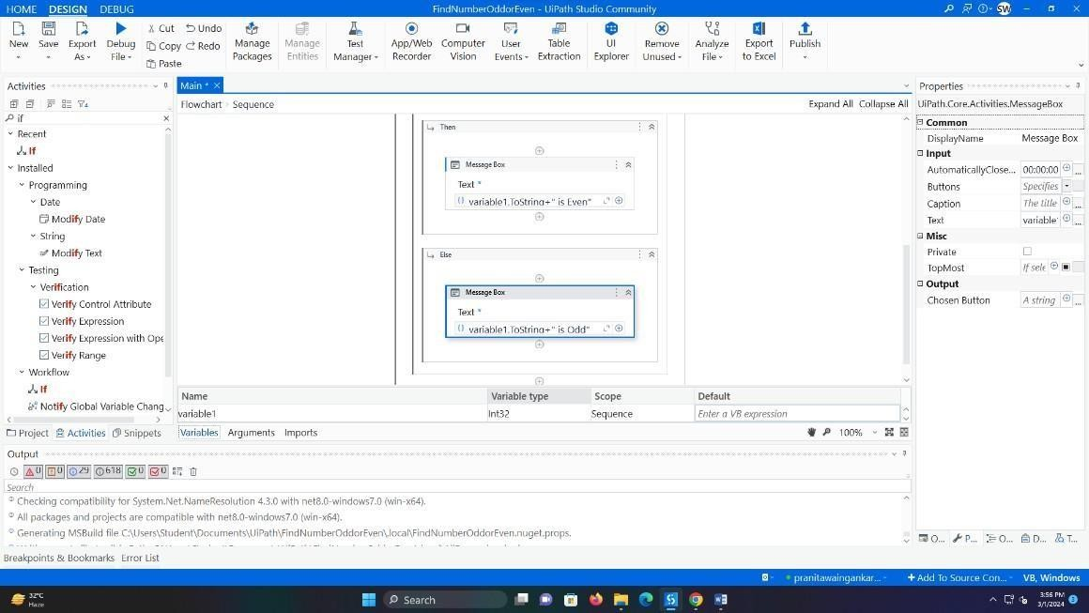

* 1. Connect the sequence to the start node by right clicking on sequence and selecting the “Set as start node” option.

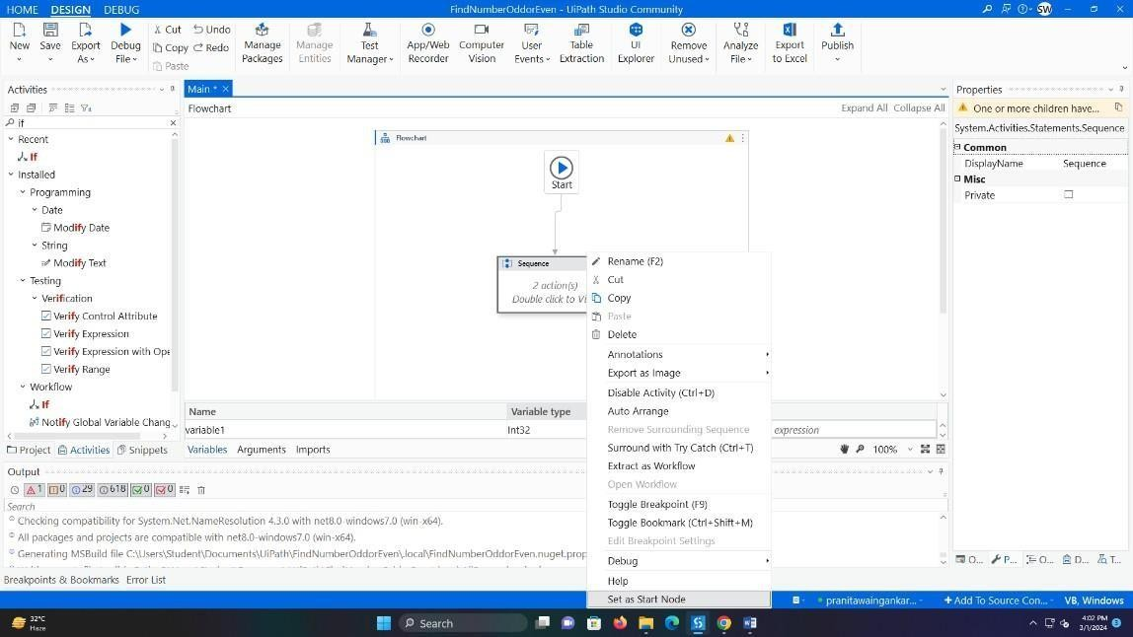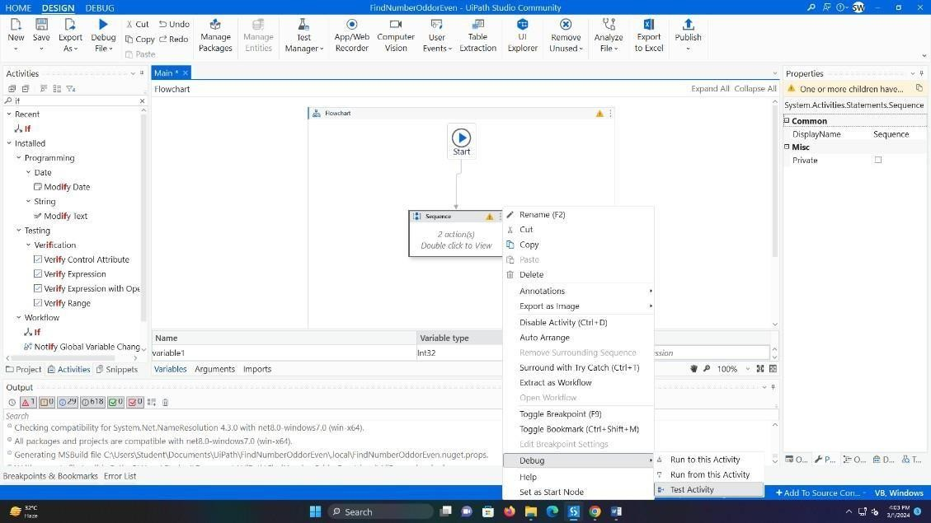

## Output:

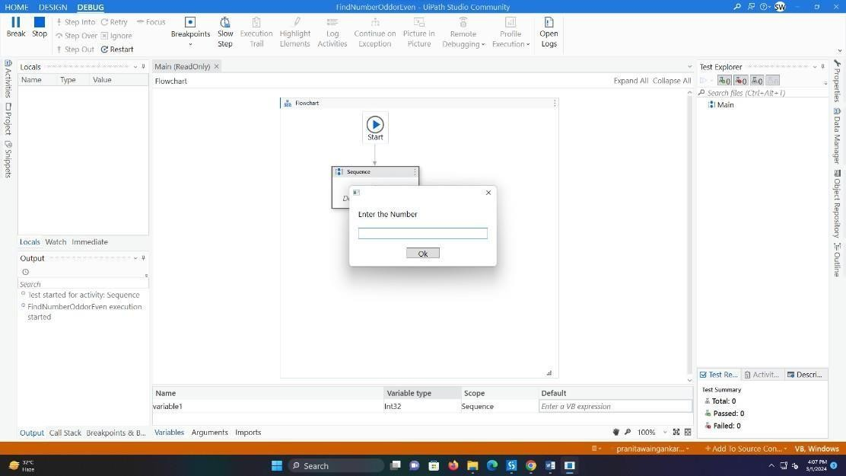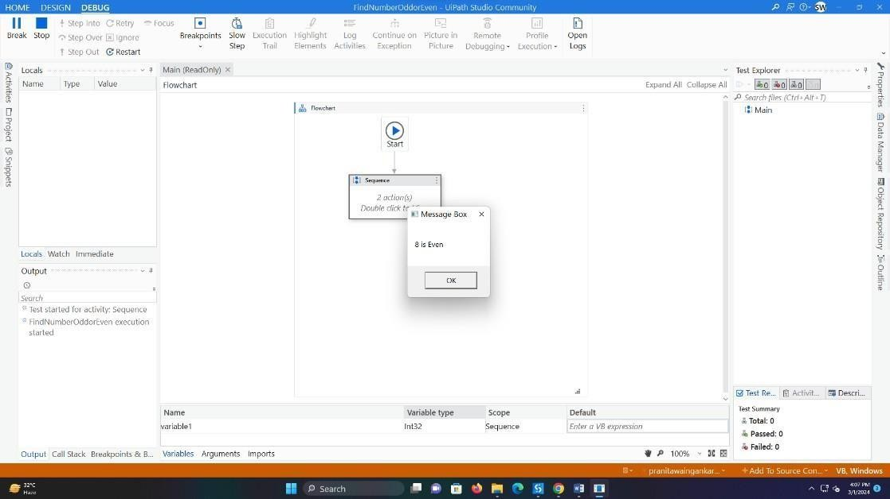

1. **Create an automation UiPath Project using looping statements.**

**Aim:** Create a dummy List offruits. Loop each and print in Message Box. Steps:

1. Create a new Blank Project and give it an appropriate name. Drag aSequence activity from

Activity tab.

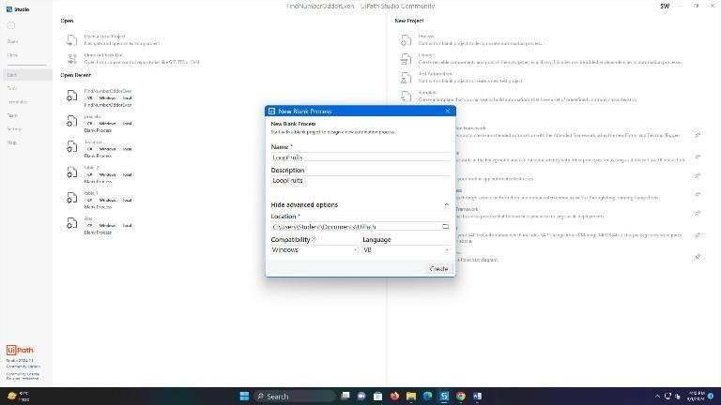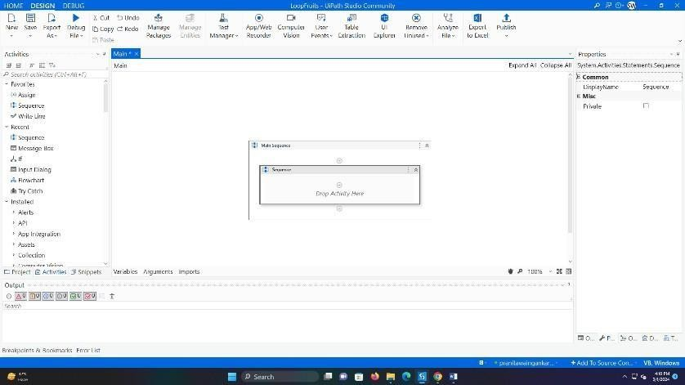

1. Create an Array of String Type named fruits. Give default value as{“Apple”, “Mango”, “Banana”, “Orange”, “Watermelon”}.

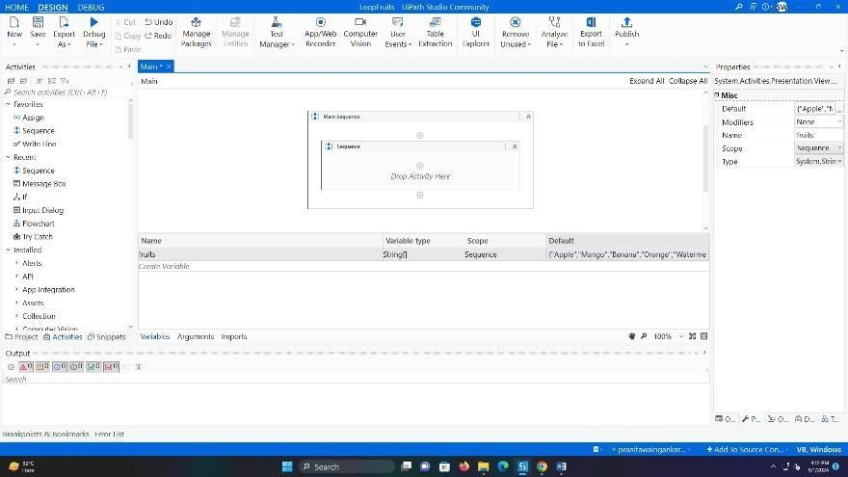

1. Add a for each activity and enter the fruits array as the iterating variable

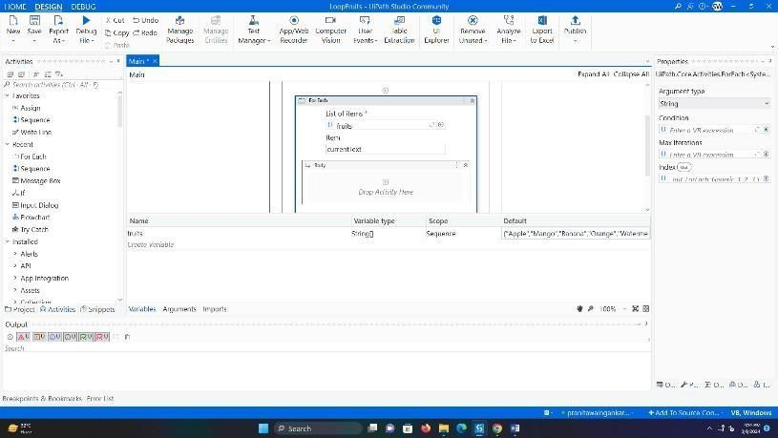

1. Add a Message Box and print item.

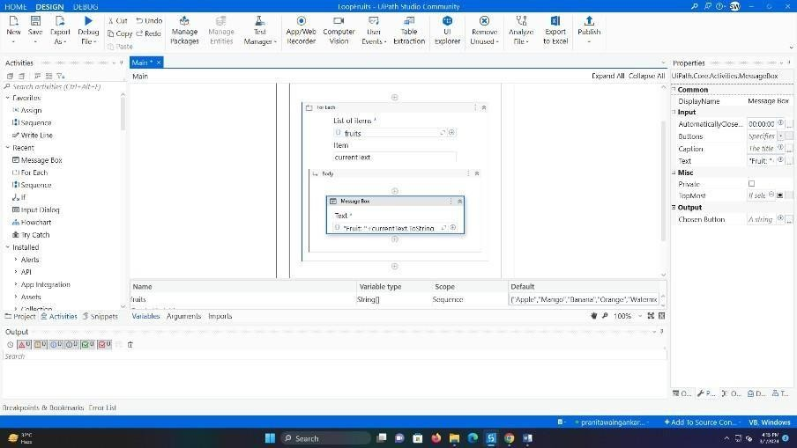

Output:

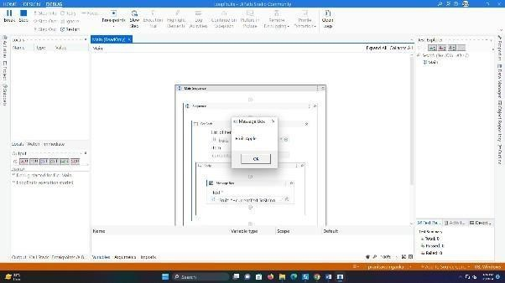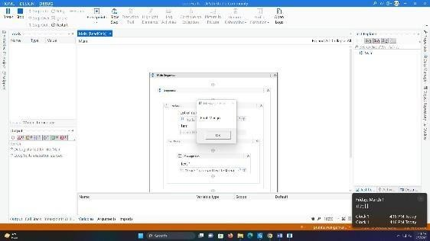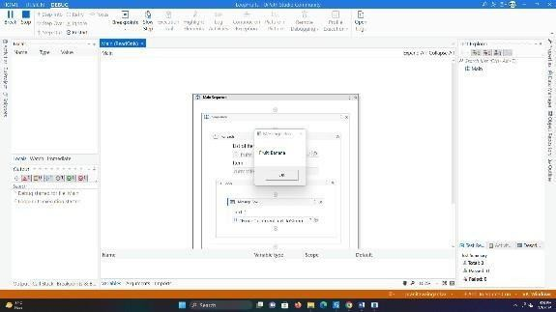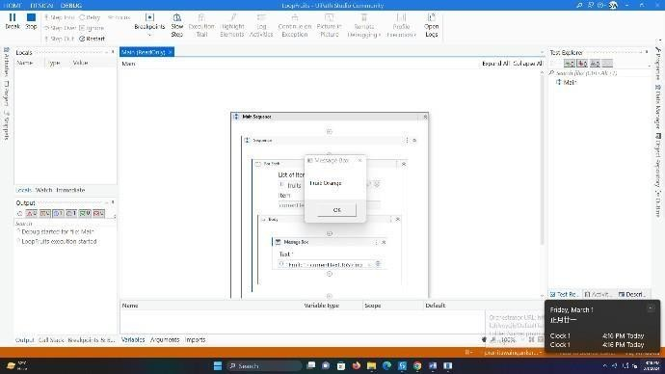

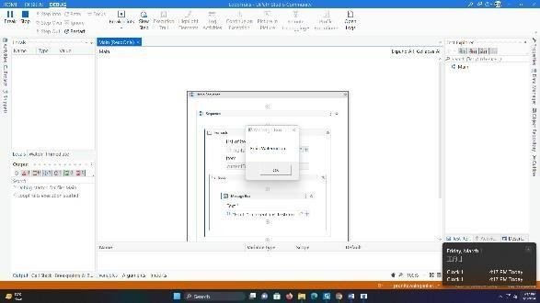

## Practical: 4

1. **Automate any process using basic recording. Aim:** Automate Existing Notepad using basic Recorder Steps:
   1. Create a new Blank Project and give it an appropriate name. Drag a Sequence activity from Activity tab.

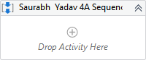

* 1. Open Notepad, And go back To The UIpath
  2. In the **Design** ribbon tab, click on App/web **Recorder**

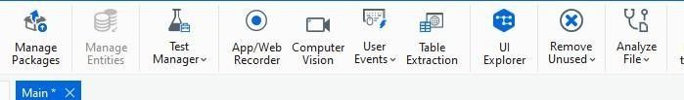

* 1. In Notepad, click on the main panel. A pop-up window is displayed.

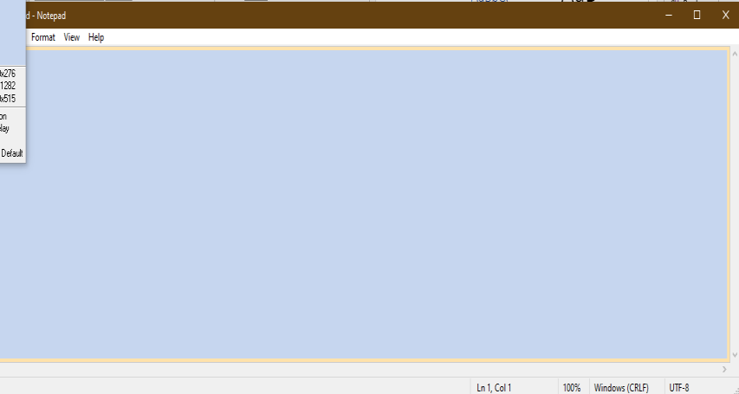

* 1. Type a custom text and press Enter. The string is displayed in Notepad
  2. 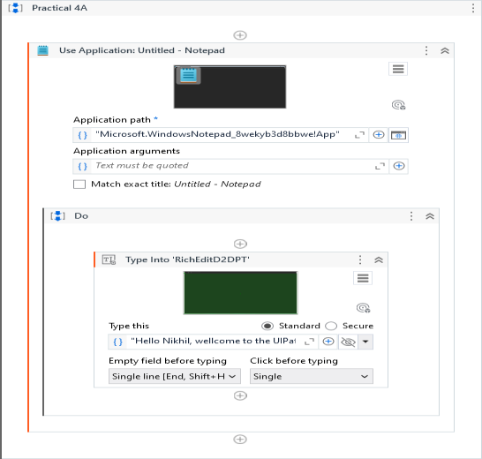Press Esc two times. You exit the recording view and the saved project is displayed in the **Designe panel**.
  3. 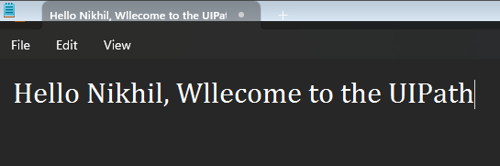Press F5. The automation is executed as expected. Output:

## Automate any process using desktop recording.

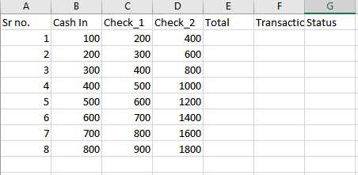**Aim:** Use "double Ui" and automate stuff (Scrape Text, Input Text, Click Button) Insert the data from the following excel file.

Steps:

* 1. Create a new Blank Project and give it an appropriate name. Drag a Sequence activity from Activity tab.



* 1. 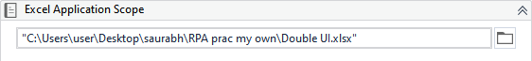Add Excel Application Scope Activity and enter the path of the excel file.
  2. Add Read Range and create a DataTable to store the data that will be read by read range.



* 1. Add Open Application activity, start Double UI then click on “Indicate window on screen” option and select Double UI.

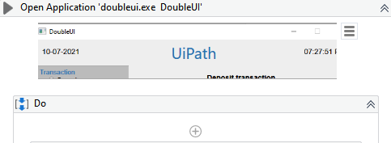

* 1. 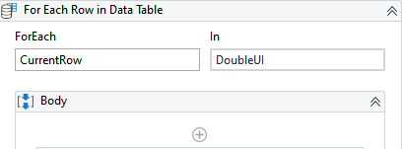Add For each row in DataTable activity and iterate over DoubleUI datatable.
  2. 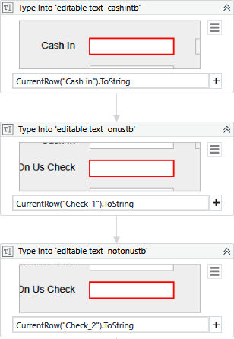Add three type into activity in the for each activity. Indicate to the three textboxes in the Double UI app. Enter the DataTable element you wan to enter in the Text attribute.
  3. Add two get text activities and create two variables to store the transaction is andtotal. Indicate these elements to the Get text activities.

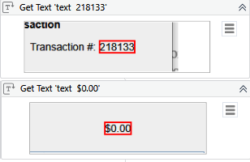

In case of Total remove the name attribute from the Edit Selector.

* 1. 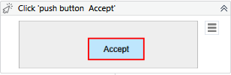Add Click activity and indicate to Accept Button in Double UI.
  2. Add three Write Cell Activities to enter the transaction id and total and to Update the status column. ("E"+(DoubleUI.Rows.IndexOf(CurrentRow)+2).ToString)

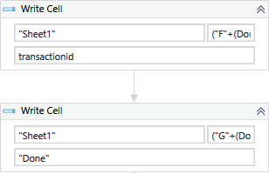

* 1. Finally add a Message Box to print the success of the updation of Excel file.

# Output:

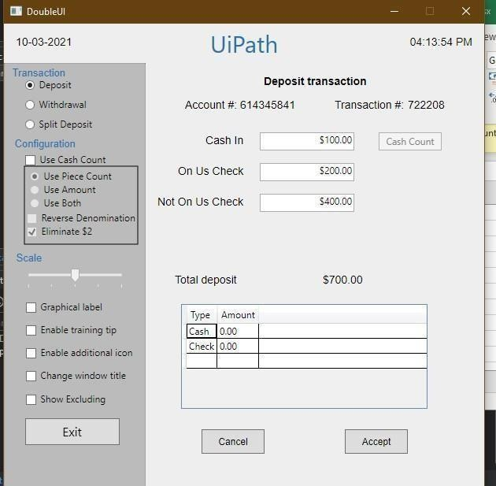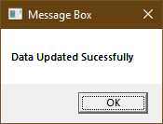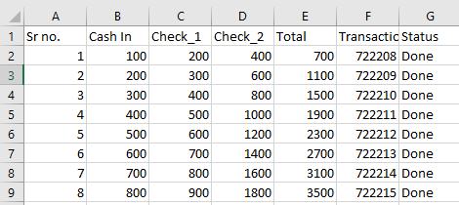

## Automate any process using web recording.

**Aim:** Use "google.com" and automate stuff (Scrape Text, Input Text, Click Button) Steps:

1. Create a new Blank Project and give it an appropriate name. Drag a Sequence activity from Activity tab.



1. Open google on crome, And go back To The UIpath
2. In the **Design** ribbon tab, click on App/web **Recorder**



1. 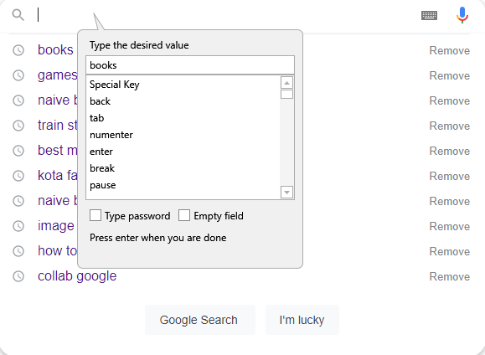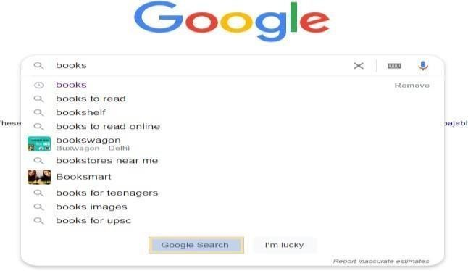Now start recording by clicking on Record and click on the search button. Type the desired search and click on the Google search button. The press Esc.
2. Now press save and exit. Add get text activity and select the text you want to scrape.

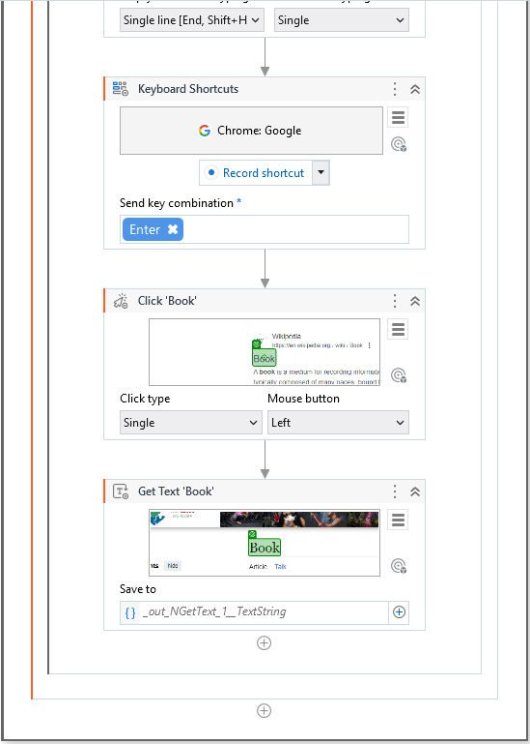

1. Add message box to print scrapped text.



## Output:

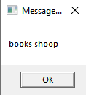

**Practical no 5**

**Aim:** Consider an array of names. We have to find out how many of these start with the letter “a” Create an automation where the number of names starting with “a” is counted and the result is displayed.

## Steps:

1. 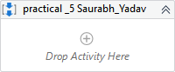Create a sequence.
2. Use 1 Assign Activity Create array string Eg:

{"Arun","Akbar","Pankaj","Bharat","Saurabh",”Meeth”,”Akshay”}



1. In Variable section take datatype as Array of[T] -> String



1. 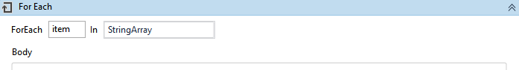Take For each loop where each item in stringArray will occur repeatedly.
2. Take another Assign activity and create new variable as “First_letter_name” with datatype as String.

 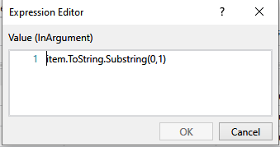

item.ToString.SubString(0,1) Where 0 is the starting index value. 1 is the length of the name.

1. Now Take If condition -First_letter_name.ToLower.Equals("a") this condition states that take the letter from the name list of array which starts with alphabet “A”or “a”.

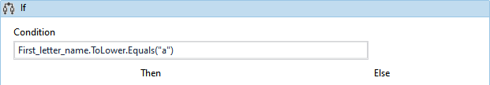

1. Then: take assign activity create Counter variable to count the numberof names in the array starting with “A”, give default value of Counter variable as 0

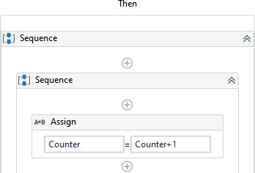

1. 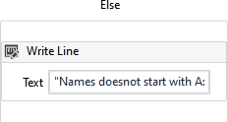Else: take write line activity and put as " Names does not start with A:"+item.ToString
2. Add a message box after the if activity and show the count of Names



starting with “A”.

1. 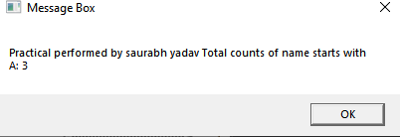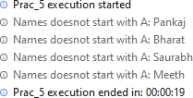Hit the Debug button and see the result.